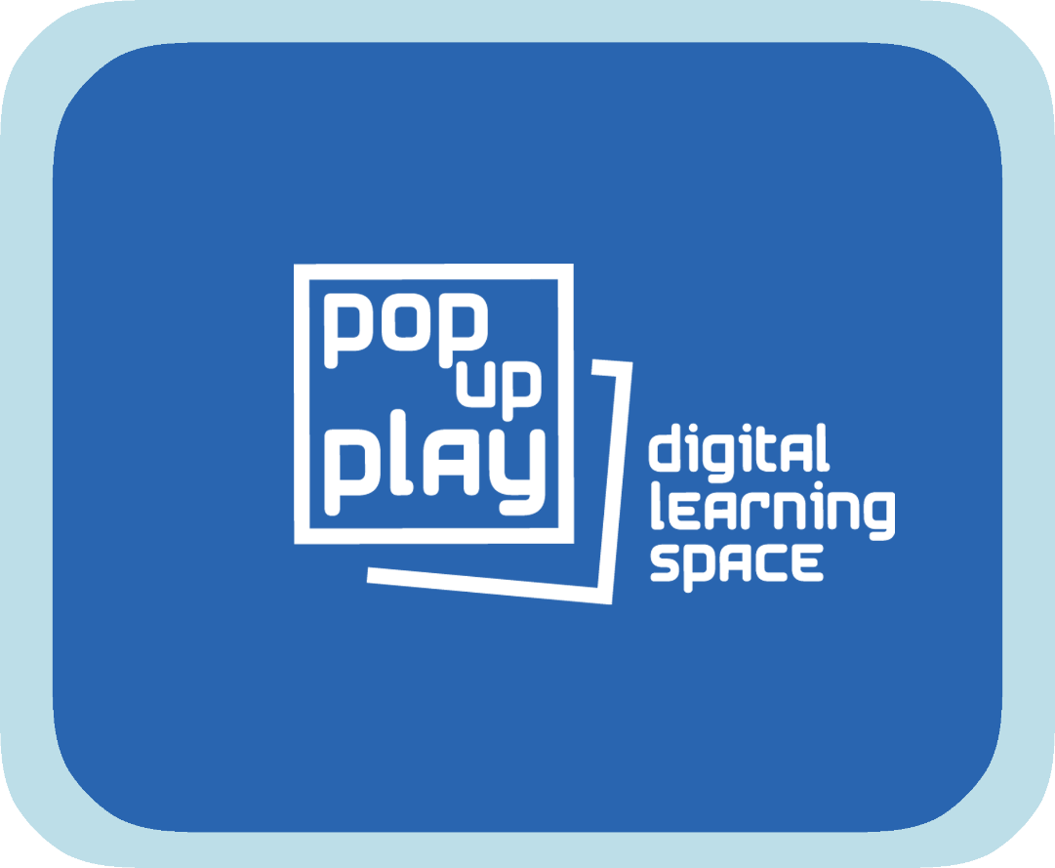
Pop Up Play Software User Manual

Summary 2
Potential Hardware 5
Hardware notes 6
Installing the PUP software. 6
Third party software required.........................................6
Minimum system requirements ….................7
Media..............................................................................8
Media file formats ….8
Setting up equipment. 9
Using an iPad................................................................ 11
Opening and testing the PUP software 12
Using the PUP software 14
The Visual System 14
The Cut Out System.......................................................15
The Puppet System 16
The Audio System 17
The Lighting System.......................................................19
Adding media to the library 20
Troubleshooting 22
Frequently asked questions...........................................22
Additional information 23

Summary
The Pop Up Play (PUP) software facilitates the creation of a mixed reality environment where a combination of the digital and the real can come together to stimulate creative play and communication. It allows for participants to be immersed in scenarios that can be expanded upon with almost limitless possibilities.
The software makes use of interactive visual, audio and lighting elements which can be loaded up with media content (images, video, sound etc) as desired and combined with real time input for a very flexible system. The system attempts to use accessible and low cost technology and is designed to be modular so that a basic setup could consist of a small part of the available components, though at a reduced set of features.
The only restriction with the PUP system is how big your imagination is.
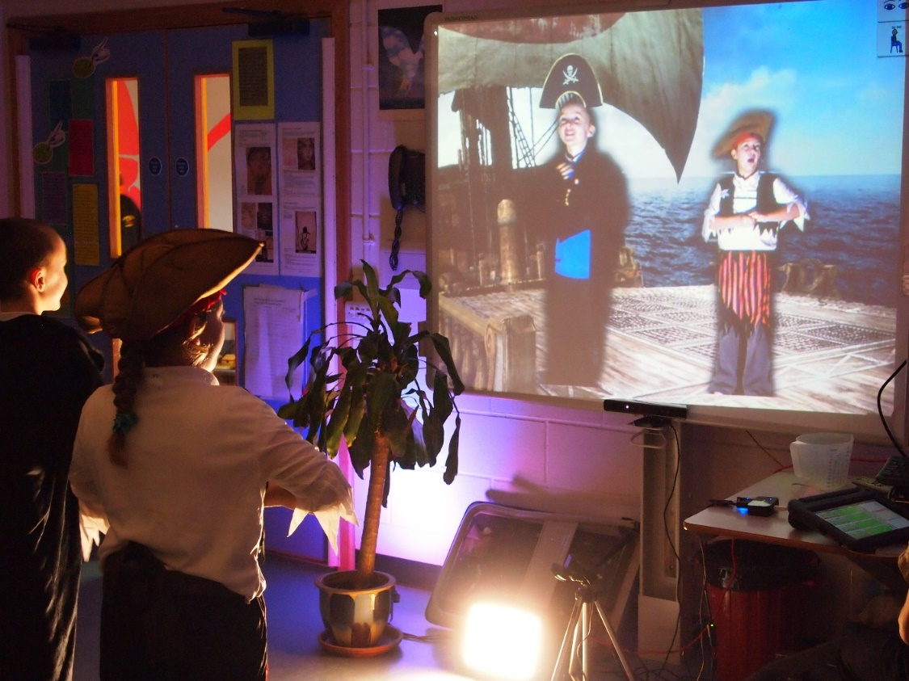

The system is comprised of 3 parts: a video system, an audio system, and a lighting system. All systems have a bank of selectable settings and media that can be linked together to provide one button scene changes. Adding the capability for accessible controls on the iPad enables the workshop leader to be mobile whilst running the session and also for the young people themselves to be able to take control.
The visual system makes use of a 3D depth sensor, namely the Kinect camera. This enable us to bring the participants into the screen whilst cutting out the background. From here we can mix elements of the digital and real world together and due to the body tracking capabilities of the Kinect camera we can also track items onto a users body or indeed do full body digital puppetry. The video system can also make use of a usb camera (e.g. a webcam) or visualiser as input enabling us to bring real world items into the digital environment.
The audio system gives us a bank of ambient background sounds and two further banks of sound effects that can be used over the top as well as microphone input. As with all parts of the system, all that is required to change or add to media, is to simply add or remove things from a folder structure and the software will pick them up. For example, users of the system could create their own body parts for a digital puppet and just copy them into a folder.
The lighting system is designed to work with DMX lighting like that used in theatres. The system is limited to 4x 6 channel DMX fittings with a Red, Green and Blue channel (RGB), though by setting up the DMX devices with the same addresses you could have any number with 4 individual output colours. The lighting system is very simple to use, traditionally unlike a dedicated DMX system. With the use of a single finger a user can scroll through all the colours of the rainbow effortlessly.

Example of a simple setup:
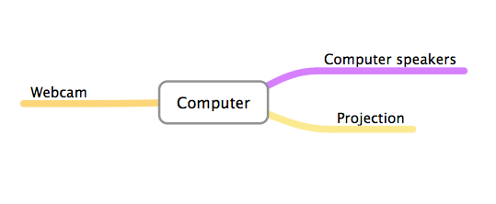

Example of a full setup:
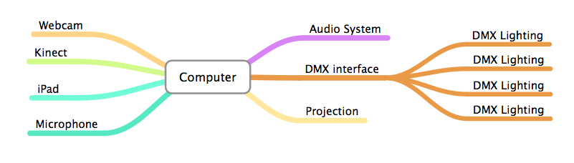

Potential Hardware
Within this guide are general set-up instructions for the software and hardware that PUP can make use of. Not all users will have the same hardware or software setup so specific items that you own may need to be configured using the manufacturers instructions. If you have any trouble setting up your hardware, then refer to the troubleshooting guide at the end of this document or you may be able to get help on the discussion board of the PUP website.
The list below shows the hardware that can be used with the system, though with it being modular it is not all required to run a basic setup:
- Computer – Windows computer running at least Windows 7 (Wifi enabled or networked if you intend to use an iPad)
- Kinect v1 camera/sensor (see hardware notes) - The system is designed for the 'Kinect for Windows' device and no the 'Kinect for Xbox'. If you are a developer see 'Additional Information'
or...
- Kinect v2 camera/sensor - This model of the Kinect camera should only be used with computers running at least Windows 8 and with a USB3 port (see hardware notes). The system is designed for the 'Kinect for Windows' device and no the 'Kinect for Xbox'. If you are a developer see 'Additional Information'
- Webcam – Be aware that a higher resolution webcam will tax your system more and a lower resolution one may look pixelated, choose accordingly for the capabilities of your computer
- Mains powered USB Hub (may not be required if using limited setup or your computer has enough USB ports)
- DMX Lighting control box – this system is designed to work with the Enttec DMX-USB Pro or Pro 2 (UK supplier: http://www.shocksolutions.co.uk )
- DMX Lighting fixtures – 6 channel DMX lighting with a Red Green and Blue channel (e.g. par can, colour wash, RGB lighting bar etc) NB: mixing fixtures with RGB on different channels is not supported at this time
- DMX cable adapter – If your lighting fixtures use 3 pin instead of 5 pin DMX, you will need an adapter like this http://www.shocksolutions.co.uk/sales/accessories/5-to-3-pin-dmx-adaptor-detail
- Performer lighting – studio style lighting (eg LED panel, white umbrella style lights)
- Projector and screen or large format monitor – If using a projector, you will not want it in the performance area so you will probably want a ceiling mounted or ultra short throw one
- Audio system (eg amp and speakers, PA system, active speakers)
- iPad

Hardware notes
There are two types of Kinect Sensor available, the Kinect for Xbox and the Kinect for Windows. The use of software on Windows legally requires the Kinect for Windows and hence is what this system is designed for. If you are a developer then see the 'Additional information' section.
The Kinect v1 model is of lower resolution than the v2 meaning that the cut out image of the performers may be of lower quality and may appear pixelated on large screens. The v2 also has tighter tracking and deals with lower light levels better, but this all comes at a cost. The v2 needs at least Windows 8, USB3 and uses more processing power so will require a higher spec machine.
Both models of Kinect require a lot of bandwidth on the USB port they are plugged into and therefore will not like sharing a hub with another camera. Ideally they should be plugged directly into a USB port, though they should work alongside the DMX interface. Sometimes a machine will have extra USB ports due to an internal hub so it is worth trying different hubs if there are any issues.

Installing the PUP software
The PUP system is provided in the form of a zipped file which includes all the things you will need to make it run. It is advisory that you unzip and extract these files before use rather than run them directly from the zip folder. To do this, right click on the zip file and select 'Extract Files'.
The PUP software itself is provided as a folder that includes a simple 'PUP.exe' file. However, it does depend on some third party components in order to work properly and details of installing them follow. Move the whole 'Pop-Up-Play' folder to a location of your choosing and then you can run the 'PUP.exe' file from there.
[Developers - The PUP software was built in Cycling74's 'Max' programming environment. If you are interested in contributing to the PUP system please refer to the 'Additional info' section of this manual]

Third party software required
To enable the full functionality of the PUP software, several pieces of third party software are required. The installers for these are included as individual files. It doesn't particularly matter in which order you run these, and they may not all be required depending on your setup, but the software will not work fully without them all in place. Double click on the .msi files and follow the instructions to install the software. Links to the original downloads are provided should you want more information.

Apple QuickTime for Windows
The video engine of the PUP software currently makes use of QuickTime.
http://support.apple.com/kb/DL837

Apple Bonjour
To enable an iPad to communicate with the PUP software you will need to install Bonjour services.
http://support.apple.com/kb/DL999?viewlocale=en_US&locale=en_US

Kinect for Windows Runtime
If using the Kinect for Windows you will need to install the required software and drivers.
For Kinect v1, at the time of this manuals release, you will need version 1.8:
http://www.microsoft.com/en-gb/download/details.aspx?id=40277
For Kinect v2, at the time of this manuals release, you will need version 2.0:
http://www.microsoft.com/en-gb/download/details.aspx?id=44559

dp.kinect
This component enables us to speak to the Kinect Sensor and is actually included in the software so does not need to be installed, but a licence is required which will need to be purchased and registered. Depending on which version of the Kinect you are using you will need to buy a certain version, either dp.kinect for the v1 or dp.kinect2 for the v2.
Follow the link to purchase the appropriate licence and once you have received it open the 'dp.kinectRegister.exe' file and follow the instructions:
https://hidale.com/product-category/software/

FTDI Drivers
To enable you to use the recommended lighting equipment you will need to install drivers that enable your computer to transmit serial data correctly.
http://www.ftdichip.com/Drivers/VCP.htm

Minimum system requirements
Depending on how you are using the PUP system, the demands upon your hardware will differ. The specifications below are separated into Kinect v1 and v2 use and are aimed at using the system with consideration to the guidelines around file types/sizes and video codecs as outlined in 'Codecs and File Formats' section of this manual. Other software factors can have an adverse affect on the PUP system such as Anti Virus Software running or system checks etc. Remember that PUP is potentially rendering several layers of video at once which is an intensive task and any other software should be closed while it is in use.
It is recommended that your system meets or exceeds the following specifications:
Kinect v1
CPU: 32-bit or 64-bit processors, dual core, 2.66GHz or faster
Ram: 4GB
Hard Disk Space: 1GB
Graphical processor: must support DirectX 9.0c (a dedicated graphics card with at least 512MB VRAM is recommended, though the software should work with an integrated one at reduced performance)

Kinect v2
CPU: 64-bit processor, Physical dual-core 3.1 GHz (2 logical cores per physical) or faster processor
Ram: 4GB
Hard Disk Space: 1GB
Graphical processor: must support DirectX 11 (a dedicated graphics card with at least 512MB VRAM is recommended, though the software should work with an integrated one at reduced performance)

Media
The PUP software relies on a folder structure within the 'Media' folder containing image and sound media files as well as saved settings for the lighting. There are a limited number of media files and lighting setups supplied with the system, but if you want to add your own you simply need to drop files in the appropriate folder. Once the folders are adapted, the changes will be picked up automatically when the software loads or when the 'Reload Folders' button is pressed on any page of the controls. The folders are named in a way that should be self explanatory when referenced with the software use, but more detail can be found in the 'Adding Media' section of this manual.
NB: When using the PUP software it is important to recognise that file formats and codecs can have a great affect on performance. Please refer to the 'Codecs and File Formats' section of the manual to get the best from the system.

Media File Formats
When using the PUP software it is important to recognise that file formats and video codecs can have a great affect on performance. These guidelines should enable you to get the best out of your hardware setup.
When saving files for the PUP system you may be using software that isn’t listed here, if unsure of how to export footage in the correct formats refer to manuals or guides for the software packages that you are using.

Still Image Files
When saving from digital image processing software like Photoshop or Gimp you can select dimension, file type and quality settings. The PUP software has been optimised for image dimensions of 1024x768 and medium to high quality. If your machine has good specifications then you may be able to use higher resolution images and the software will adapt to support it. Generally for background images we use the JPG format.
Transparency – if you want your images for the overlays, 'disguises' or puppet components to be 'cut out' then you need to use a file format with an 'alpha' or transparency channel, for this we use the PNG format.

Sound Files
The recommended file types for audio are WAV or AIFF stereo files saved at 16 bit and 44.1 KHz which is often known as CD quality. These settings can be selected when exporting from programmes like Audacity, Logic, Reaper, Quicktime etc.
Again, other file types may be supported but have not been tested at this time.

Video Codecs
The PUP system uses a MOV format for its video files, but this is essentially a wrapper around a codec of which there are many types, which can lead o some confusion. Some codecs compress files very well (eg H264) which gives you small files, but at a cost of more processing power to uncompress them as they play. Other formats are the reverse (photoJPG) which give you large files but easier playback. We tend to use the latter to keep performance up, but the system will permit the use of the Apple suite of codecs such as Prores and AIC which can offer a midway.
Transparency – If you want your movies to have a transparency or 'alpha' channel you will need to use specific codecs. For example you may want an animated overlay or a weather effect video, such as rain, to be superimposed on the background below. You can also use a video with transparency as one of the masking textures when you 'Disguise' a user. Effectively, video of this type has an extra channel so can be of a larger size and tax performance more than an ordinary video file. For videos with transparency we tend to use the PNG codec but the ProRes 4444 should also work. The Animation codec also has a transparency layer, but is probably harder on performance.

Setting up equipment
The PUP software can be used with as little equipment as just a computer, screen/projector and an audio system, but will support other hardware components for a more immersive environment. This section will describe a full setup of the system in a generic way that may differ slightly from your own experience. If you do not have all the equipment listed, you can ignore any components you are not using for a smaller setup.
NB: This guide will assume you have installed the necessary drivers for your chosen webcam and any other equipment as per manufacturers instructions.

USB Hub
If required, connect the USB hub to your computer and then connect the power lead.
N.B. - When connecting devices to the USB use the USB data ports and NOT the USB charging ports, these can be differentiated by the lightning icon above the charging ports.

Kinect
Place the Kinect Sensor on a stable surface central to the viewing screen, plug the device into a power socket, and the USB lead into a free USB port. If you can, use one that goes directly into the computer rather than a hub, but we have tested through several hubs successfully. It is important NOT to share the hub with the webcam as they will both be trying to get a lot of information into one port.

Webcam
Connect the Webcam to a free USB port on the computer, again if you can go directly into the computer then do so. You can use a USB extension for extra reach, but if you go beyond 5m you will need an active cable or another powered USB hub.

DMX Lighting
To use DMX lighting as described in the 'Potential Hardware' section, you will need a DMX interface. Using the supplied micro USB lead connect the DMX USB Pro/2 interface to a spare USB port and connect the supplied break out cable to the other end. Connect the 'DMX 1' male 5 pin connector to an appropriate DMX or XLR cable and plug into the 'DMX In' port of the first lighting fixture (you may need a 5 pin to 3 pin adapter depending on your lighting fixtures/cables, see 'Potential Hardware' for details). To connect the other lighting fixtures connect a further cable from the 'DMX Out' of the first light to the 'DMX In' of the second and so on, continuing this process to daisy chain further DMX lighting fixtures.
To enable the DMX lights to function correctly you will need to select the channel on which they will operate. The specific way that your lighting fixtures handle channel allocation may differ greatly between units, modern fixtures will generally have a screen that allows you access to a menu system, whereas older lights may only have DIP switches. Please refer to manufacturers instructions where required, but generally if you can find the menu labelled 'ADDR', 'CHAN' or similar, this is where you set the channel number or 'Address'
Remember that the lights should be 6 channel fixtures or set to a 6 channel mode, this means that the first is set to one and the second set to channel 7 and so on. Below is a table showing the channel numbers if several six channel lights are used.
Fixture Number | 1 | 2 | 3 | 4
Channel Number | 1 | 7 | 13 | 19

NB: It is in fact possible to set several fixtures to the same address channel and they will simply all go the same colour, so you can in fact have any number of lighting fixtures.
You may want to arrange the channels on the fixtures so that they match the layout in the 'Lighting System' section of the software.

Connecting audio device
Connect the computer to your audio system using the appropriate cable for your system. Alternatively you can send the audio through the HDMI lead and use the speakers on your display device if your computer has an HDMI port.
If your sound does not come through or you want to change the audio output device between HDMI and the built-in output you can click on the 'Audio Driver Settings' button in the computer based 'Audio System' section of the 'Pop up Play' software. What you see here will vary depending on the setup of your system, but we are primarily interested in setting the correct 'Driver', 'Output Device' and 'Input Device' (if you want to use a microphone). The 'Direct Sound' driver should suffice and the input and output devices should be fairly self explanatory by their naming.
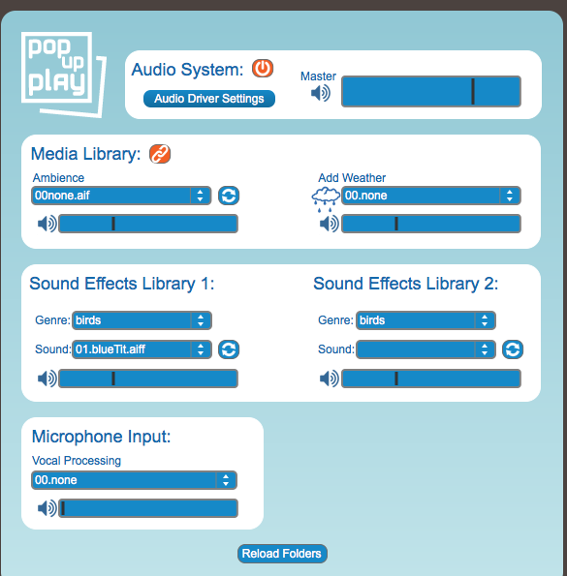

Using an iPad
To enable mobile control and interaction it is possible to use the PUP system with an iPad. The iPad controls also offer a simplified view which may be more appropriate to give to children. To make use of these controls, you will need to download and install a paid third party app called MIRA which is available through iTunes. Details can be found here:
https://itunes.apple.com/gb/app/mira-controller/id649586480?mt=8
Note – You will need to have an iTunes account and a bank card associated with it to be able to purchase the app.

Installing the App
This can be done from the iPad or from a computer with iTunes on it which can then be synched with the iPad.
- Locate the MIRA app by searching on the iTunes store
- Select the MIRA app
- When ready select the button that has the price, this will start the installation process on your device
- You will need to enter your password for the iTunes account to allow it to install
- Once it has downloaded and installed go to your Apps and select MIRA
If your iPad and computer are connected to the same network then when MIRA opens it should connect to your computer and the PUP controls should open and be ready to use. If you are finding that the controls are not very responsive or that they frequently crash then it may be that your Wifi network is a little on the slow side and you may be better off making a direct connection to your computer, this is described as an 'ad-hoc' network.

Setting Up an Ad-Hoc Network
In Windows 7 setting up an ad-hoc network is fairly simple and you may want to manage this yourself, if so, follow these instructions: http://windows.microsoft.com/en-gb/windows/set-computer-to-computer-adhoc-network#1TC=windows-7
However, in Windows 8 this is more problematic and would require typing DOS commands or using a third party piece of software such as 'Connectify' or 'Virtual Router'. For this reason we have included a helper file that will do this step for you on Windows 7 or 8.
Double click on the 'ad-hocSetup' file to set up a network called 'LocalAdHoc' with a password of 'popupplay'. Find 'Settings' on your iPad and then go into the 'Wifi' section. Under 'Choose a Network', you should see this network pop up and you can click on it to connect and enter the password. You will need to wait for a minute or so before trying to open the MIRA app as it will need a chance to get an IP address. When you want to close this network you can double click on the 'ad-hocClose' file.

Opening and Testing the PUP Software
Run the PUP software by double clicking on the Pop_Up_Play.exe file, once running it should open a control window and a black viewer window.
When using an extra display you can set your computer to mirror the same screen to it, or to use it as an extra desktop. In this instance it is best to use it as an extra desktop so you can have the controls on one screen and the viewing window on the big screen. Again, the setup for this may vary between systems, but right clicking on the desktop should offer you 'Graphics Properties' from where you can choose settings for multiple displays.
If your display is mirrored then pressing the 'esc' key will make the viewer window toggle between full screen mode, but will hide the controls. If you have multiple desktops setup then you can drag the viewer window onto the connected display by clicking and dragging on the top of the viewer window and moving it off the screen towards the direction where the second desktop was setup (generally off the right or left of the screen).
When the window is fully on the correct display, press the “Esc” key to allow it to go into full screen mode.
Proceed to test that the software is running by selecting a background image from the background media library drop down menu.
Try turning the Kinect on by using the power button on the control window and test that the video is coming through by having someone move around in front of the sensor. The Kinect system will default to using the Kinect v1 sensor, but within the 'Settings' window you can choose which version you are actually using. Within this window you can also adjusting some of the colour camera settings like brightness and contrast and toggle a near or seated user mode. In the case of the Kinect v1 you also have the option of tilting the camera up or down here. You can also do this forcefully by hand which is not recommended by Microsoft, but we have done it for years now with no ill effects. To ensure that the performer shows up well on the screen, use the studio lighting to illuminate the front of the subject. There are also brightness and contrast settings within the Kinect 'settings' window.
If there is no illumination on the subject they will still appear on screen but they may appear as a silhouette.
NB: the Kinect on/off button has a slightly different function between the iPad and the computer controls and it must originally be turned on from the computer in order to function. From the iPad the on/off button functions the same as the 'Show User' button on the main software controls, whereas on the computer controls it actually turns the Kinect camera on or off and repeated pressing could cause the software to crash.
Check to see if the Webcam is working by selecting the correct device from the list and turning it on. If you have plugged your camera in after the system has started you may need to reload the menu with the button.
Move to the 'Audio System' and select a sound effect to check your audio system is working.
Now move to the 'Lighting System', you may need to select the correct port for your DMX interface (make sure it is plugged in!) and your RGB channels for your lights. For the interface, press the 'Reload Menu' button and choose your device from the menu (ours generally shows up as 'COM4'). To select the correct channels for red, green and blue colours, click on the 'Choose RGB Channels' button. This will ask for your Red channel on your lighting and then the channel for the main fader, it will then set the RGB channels and turn the main fader to a value of 255. This step depends on knowing what the setup of your lighting fixtures is, refer to the manufacturers documentation for details of each channel and what they do.
Example
Choosing 1 for Red channel and 5 for Main fader channel will allocate:
- Fixture 1 channel 1 to R, channel 2 to G, channel 3 to B and channel 5 to a value of 255 (main fader turned up full)
- Fixture 2 channel 7 to R, channel 8 to G, channel 9 to B and channel 11 to a value of 255 (main fader turned up full)
and so on

See 'Troubleshooting' section if anything is not working.

Using the PUP Software
The PUP software makes use of several different systems to create scenes that are comprised of audio, visual and lighting elements. These different systems can be accessed by pressing the corresponding tabs at the top of the screen and the media library can be linked across the associated systems, or unlinked so as to control each element individually. New media elements can be added as described in the 'Adding Media to the Library' section of the manual, once added you can press the 'Reload Folders' button on any page of the controls to load the media or they will automatically be found when the software is restarted.

iPad controls:
NB: There are some differences between the computer and iPad based controls. The iPad controls are in general simplified and have had most system settings removed so that they can be experimented with without causing problems to the running of the software. Generally this section will address the computer controls as they are the more full. Where there are important differences in this section, a separate note will be made.
The iPad offers pinch and rotation gestures which can be used in place of a scale fader and as a way of rotating visual elements within the position/scale/rotation control areas. In cases where there is a position and scale control on the computer, this has been replaced with this functionality on the iPad. Instead of using a slider to change the scale you need to use two finger gestures, simply place two fingers on the square and move them apart from each other to scale the object up and increase its size, or move them together to reduce the scale and so decrease its size.
To rotate elements place two fingers on the square slightly apart and rotate your hand.

The Visual System
The visual system enables the control of background visuals, transparent overlays (such as weather effects) the Kinect sensor and a webcam. From the 'Visual System' section you can export an image of whatever is currently on the screen and with the following dialogue box choose where to save it, see the 'Adding Media to the Library' section of this manual if you want to incorporate it into the system.

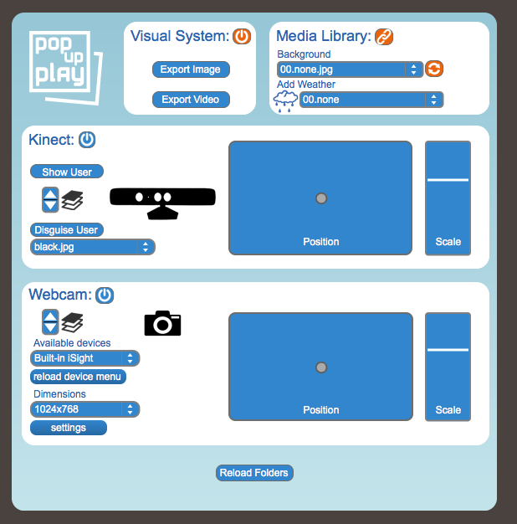
The drop down menus in the 'Media Library' section allow you to select from files that are saved in the media folders (see 'Media' section of this manual). Pick a background and it will fade in and trigger corresponding media in the ambient sound and lighting components if it is available. If you would rather the background component did not link to the sound and lighting components then you can deselect the chain 'link' symbol. As movie files can also be used as backgrounds, you may want control of looping and this can be controlled with the looping symbol next to the drop down menu. If you wish to go to a black screen, simply select the top one '00.none'.
Also within the 'Media Library' section, the 'Add Weather' drop down menu allows you to select a layer to overlay the background. We use this for an image file with a transparency layer such as a weather or environmental effect like rain or smoke. Again, if there is a corresponding sound file it will also be played. Check the 'Media' section for more information.
The 'Kinect' system will default to using the Kinect v1 sensor, but within the 'Settings' window you can choose which version you are actually using as well as adjusting some of the colour camera settings and toggling a near or seated user mode. You can then turn the Kinect on or off with the '' symbol and use the 'Show User' button to show or hide the user but still send the user tracking data to the 'Cut Out' and 'Puppet' system. There are additional controls for scaling and moving the performers image around the screen and a layer control with up and down arrows for bringing the image in front or behind other visual elements. Use the up arrow to bring them forward, and the down arrow to move them back.
NB: the Kinect on/off button has a different function on the iPad and it must originally be turned on from the computer in order to function. From the iPad the on/off button functions the same as the 'Show User' button on the main software controls.
The 'Disguise User' button allows you to use the silhouettes of the users to mask a texture beneath. Essentially this means we can see a user shaped hole through to an image file, for example we could use a black image to create a black silhouette of the users or a mist image with transparency to make the user look like a ghost. This can be used quite creatively with reference to the 'Media' section.

Cutout System
'Cutouts' allow you to place objects within the scene, these objects can then be tracked to body parts or simply moved around using the control panel for the particular cutout. Cutouts can be normal image files, but are designed for using images that have been cut out from their background and saved as an image or movie file with a transparency element. See the 'Media' section of this manual for more details on this.
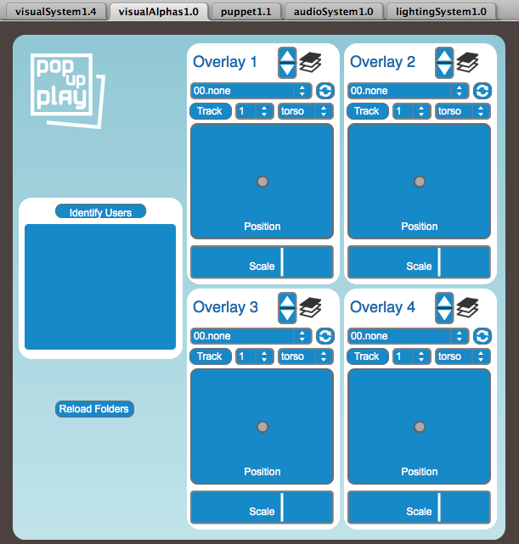
Again, there are scaling, positioning, layering and looping controls for each of the four cutouts. The cutouts are selected from the drop down menu and will load once selected. If you wish to remove a cutout, select the top one '00.none'.
NB: The iPad 'Cutout' controls are split onto two pages to offer larger control areas and greater control when using pinch/rotate gestures.
Once a cutout has been selected you can continue to assign it to track a specified user's body part by pressing the 'Track' button [NB: Kinect must be turned on from the computer based controls for this to work]. You can then choose the user and body part you wish to track from the drop down menus. Once the item is tracking a user's body part you can still use the scale and position controls to position/scale relative to that body part which is helpful with getting costume items in the right place and of the right size. If there are multiple users you can assign cutouts to each user, and you can also add multiple cutouts to a single user.
When a cutout is tracking a user, you may not want to have the image of the user displayed. Remember that you can hide the user from the 'Visual System' tab whilst still keeping the cutout tracking that user on screen.
In order to help you see which user is allocated which number, you can press the 'Identify Users' button. This should show numbered boxes which move around to match the users movements, though it is important to note that when a user exits and re-enters the scene, the user numbers may change, it is good to mark out the area of view on the floor with masking tape or chalk to help people stay in/out of the field of view. It is good to unselect the 'Identify users' button when not in use as it can help system performance, but depending on your computer it may not be necessary, refer to the minimum system specifications to see if your system meets them.

Puppet System
Similar to how the cutout system works you can place “Puppets” within the scene and have them track a user's movements [NB: Kinect must be turned on from the computer based controls for this to work].
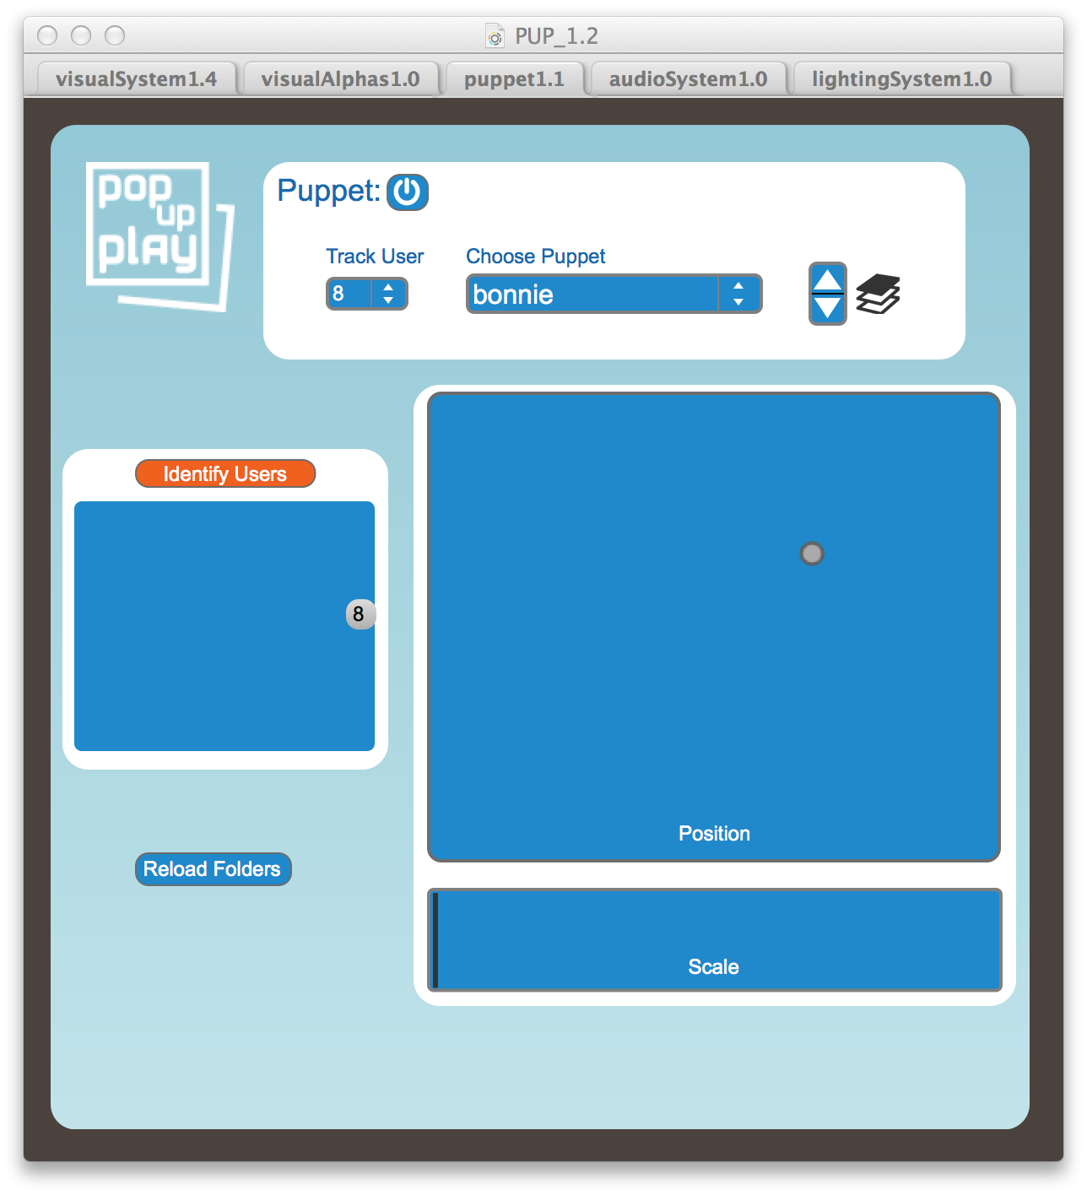
These puppets use the information from the Kinect to allow the user to actively move the puppet, the movement of the puppet relates to the users movements, for example if the user moves their arm, the puppet's arm will move too.
You can change the placement and scale of the puppet in the same way that you can change the position and scale of cutout items. And the 'Identify User' button can again be used to help with finding out which user is which.
To use this feature, turn the Puppet system on with the '' button and select a puppet from the drop down menu.
Puppets can be created and added to the library of available puppets by following the instructions in the “Adding Puppets” Section.
When a puppet is being used you may not want to have the image of the user displayed, or you may want to move them alongside the puppet for example. Remember that you can hide the user from the 'Visual System' tab whilst still keeping the puppet on screen, or indeed move the performer and puppet with the position controls in each system. This allows the user to perform alongside the puppet or be replaced by it.

The Audio System
The audio system gives access to the ambient background sounds of the media library, two sound effect libraries and a microphone input. There is a master volume fader in the main 'Audio System' box as well as access to the audio driver settings as described in the 'Setting up Equipment' section of the manual. This master fader will control the audio as a whole, but each section has its own volume control also.
The drop down 'Ambience' menu in the 'Media Library' section allow you to select from files that are saved in the media folders (see 'Media' section of this manual). Pick a sound and it will fade in and trigger corresponding media in the visual and lighting components if it is available. If you would rather the audio ambience component did not link to the visual and lighting components then you can deselect the chain 'link' symbol. The background audio ambience is automatically set to loop, but you can unselect this if you wish next to the drop down menu. If you wish to have no background sound, simply select the top one '00.none'. Likewise, selecting a sound from the 'Add Weather' menu will also trigger a visual element if it is available in the backgrounds folder as referred to in the 'Visual System' section of this manual.
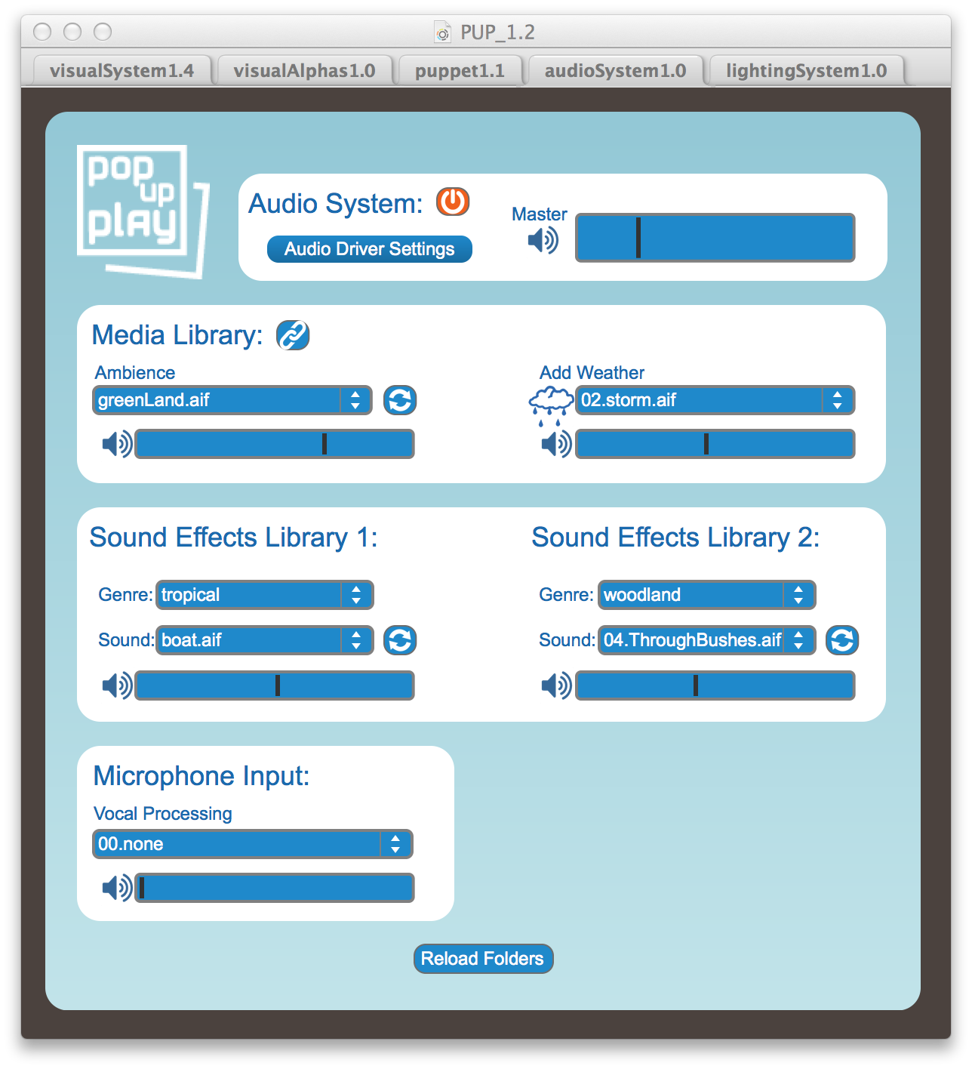
The sound effects libraries allow access to folders of grouped sounds which again have discrete volume and looping controls. The folder name is used as the 'Genre' drop down menu item which, when selected, will load the sounds contained into the 'Sound' drop down menu. See the 'Media' section for more details.
Finally, the 'Microphone Input' section allows the use of a microphone if it has been selected as an input in the audio driver settings. There is a placeholder for some vocal effects to be added at a later date, but there are none available at this time.
NB: When using the microphone input great consideration has to be taken to avoid feedback. Feedback will occur if the output of the speakers goes back into the mic, so it's effect will depend on the type of microphone, how close it is to the speakers and the volume of the input and output.

The Lighting System
The lighting system allows control of 4 DMX lighting fixtures like those used in theatres (see the 'Potential Hardware' section for more details), though in fact a single 'fixture' in this context could be several lights set to the same channel. The fixtures must have a 6 channel mode and Red, Green and Blue (RGB) channels. Fixtures of these type would be called 'par cans', 'colour wash' or 'LED bars' for example. To use this system, you must have a DMX interface as described in the 'Potential Hardware' section and have followed the instructions in the 'Setting up equipment' and 'Opening and testing the PUP software' sections to set the correct addresses on your lighting fixtures.
NB: remember that the lighting system will not work correctly with a mixture of lighting fixtures if their RGB channels are not at the same addresses.
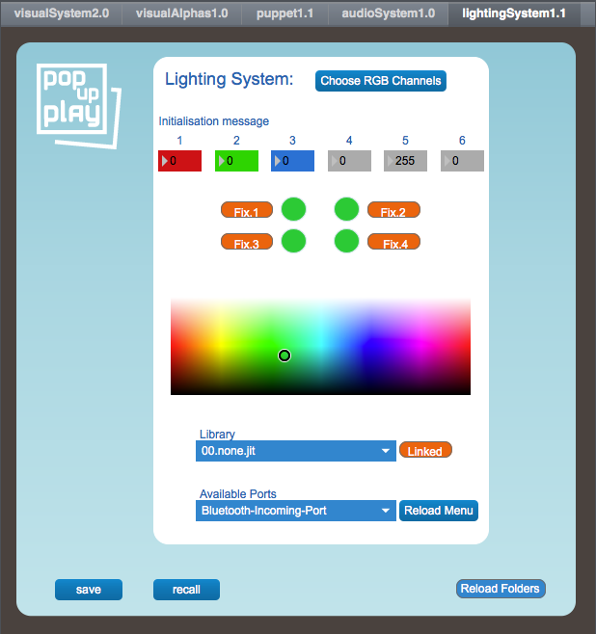
If you have followed the instructions, you should now have your RGB channels set up and your lights working with the colour swatch control.
You can in fact set individual channel information for all the fixtures using the 6 number boxes at the top where it says 'Initialisation message'. For example in the setup shown left, we have RGB channels on channel 1, 2 and 3 and the master fader on channel 5. Fader 6 may be the channel to control strobing of the lights, with 0 being no strobing, 255 being very fast strobing and relative speed in between. To control this effect you can click and drag up or down in the number box to change the number.
To control colour across the fixtures, simply click and drag in the colour swatch area, the lights should go the colour represented in the swatch. If you want to control fixtures individually then you can toggle which fixture/s you are controlling with the 'Fix.' buttons.
Again, the library is linked to the visual and audio elements and works in the same way, allowing you to unlink it with the chain link button.
The 'Save' button will allow you to save a current lighting colour scheme and a dialog will come up asking you where to put it (refer to the 'Adding media to the library' section to decide where you want it).

Adding media to the library
It is possible to add your own media element to the system for use, to do this you will simply need to place items into the correct folders and adhere to the correct file formats for each particular element. You should adhere to the guidelines in the 'File Formats' section of the manual in order to get the best performance for your system.

Background Visuals
It is possible to use your own images/movies by placing them into the “visualBackgrounds” folder.
Still images should be in the JPG or PNG format and movies in the MOV format.
Images will adapt to the screen resolution but high resolution images may reduce performance on your system and we generally work with a resolution of 1024x768
If you want to use an image that is not at this resolution it is possible to resize it by using either Photoshop, Gimp or by using a tool such as “Image Resizer for Windows”

Cutouts
Cutout still images that can be placed within the scene should use the PNG files, these allow for a transparency element.
If unsure of if a file is a PNG file open its properties tab to check by right clicking on the file, it is possible to convert images to PNG files or create your own using a program such as Photoshop or Gimp which is free.
If using video items you will need MOV files that are saved with a transparency enabled codec such as PNG or the Apple Prores 444.
The cutout files must be placed in the “visualCutouts” folder where the media library has been installed.

Background Sounds
Background sounds should be placed in the 'audioBackgrounds' folder as a WAV or AIFF format. You will get best results if you choose quite ambient sound files that loop well or create your own using a programme like Audacity which is free. Refer to the 'File formats' section for best practice.

Sound Effects
Sounds effects can be added by placing them in the “audioFX” folder. You will need t use the existing folders within or create your own folder to place them in. These folder names then become the “Genre” drop down menu which load up the sounds shown in the menu immediately below. Again use a WAV or AIFF format and refer to the 'File formats' section for best practice.

Lighting
These need to be saved in the 'lighting' folder and will need to be saved 'in app'. From the lighting system, simply click the “Save” button and you will be prompted to save a compatible file in the correct location.

Puppet System
It is possible to create and add your own puppet to the system by creating the relevant components and saving them in the 'puppets' folder. You will need to create a folder for each puppet and put the components inside. To do this you must name the files in a specific way as outlined here.
Files must be named in the following way:
calfL.png
calfR.png
foreArmL.png
foreArmR.png
head.png
thighL.png
thighR.png
torso.png
upperArmL.png
upperArmR.png

As with the overlay items, images that are being used for the puppet system MUST be saved as PNG files, these allow for certain areas of the image to be made transparent so that only the areas you want are viewable.
If unsure of how to save files as PNG format it is recommended that you look into programs such as Photoshop, Gimp or Microsoft Paint.
Photoshop templates and PNG files are available in the correct format based around A4 sizes to assist in the creation of your own puppets.

Disguises
When using a Kinect with the PUP system it is possible to mask the user with a texture as described in the 'Visual System' section. You can add your own texture by placing it in the 'disguises' folder.
Texture files can be saved as JPG, PNG or MOV files and should adhere to the guidelines in the 'File formats' section.

Weather
It is possible to add weather effects or animated overlays to the system by placing them in the 'weather' folder. These can be PNG or MOV files and if accompanied by a relevant sound file with the same name, this will also be triggered. Once again, please refer to the 'File formats' section for best practice, particularly when working with video that includes transparency as it can adversely affect performance.

Troubleshooting
The following questions and answers can guide you through overcoming some of the issues that may be face when setting up and using the software. If your issue is not covered here then you may be able to find some help on the discussion boards of the PUP website.

The Kinect isn't working
Check you have installed and setup as set out in the guidelines and that you have selected the correct Kinect model in the 'settings' window of the Kinect section of the visual system.
Ensure you are using a 'Kinect for Windows' device rather than a Kinect for Xbox.

The DMX lighting isn’t working
This can happen when the correct port isn’t selected. Ensure the DMX interface is securely attached and has a lit LED, then press the 'Reload Menu' button and try selecting another port. Ours normally shows up as 'COM4'

The Webcam Isn’t working
The webcam may not like sharing a USB hub with another device, try it in a port by itself and see if it works.
Ensure you have installed the manufacturers drivers for the webcam and try it in another application
Also, make sure you have pressed the 'Reload Devices' button and selected the correct device from the drop down menu.

The audio isn't working
Ensure you have selected the correct driver and output from the audio driver settings window in the audio system.
Ensure your audio system is on, turned up and correctly plugged in to the computer, perhaps unplug it and try through the computer speakers to make sure sound is coming out of the computer.

There are no controls on the iPad
To resolve this close the “MIRA” and re-open it. In extreme cases, restart the MIRA app on the iPad and the PUP app on the computer, if you still have issues then restart both devices.
Performance between the iPad and the computer can be restricted by the speed of your home network, creating an ad-hoc network may fix this.

My connected display is not showing up
Ensure that the cables are fully plugged in, if so try restarting your computer.
If this fails to show your connected display check your display setting in the control panel of your computer or by right clicking on the desktop.
If problems persist refer to the manual for your display.

FAQ's
Can I use a Mac? - Refer to the 'OpenNI and Mac systems' in the 'Additional information' section
Can I use a tablet other than the iPad? - Unfortunately the MIRA software will only work with an iPad at this time. We would like to offer more generic OSC controls in time which could be accessed from any tablet, but they would not offer the same level of control or visual experience.
Can I use a Kinect for XBOX? - The system is designed for use with a 'Kinect for Windows', for more details see the 'Additional Information' section

Additional information

Kinect for XBOX
If you are a developer and are interested in contributing to the system, then you may be able to use the Kinect for XBOX with reference to the terms at the following link:
https://msdn.microsoft.com/en-us/library/hh855358.aspx

OpenNI and Mac Systems
We started development of the software when OpenNI was still a possibility and would allow use of the Kinect on a Mac. During the development cycle, Apple purchased the NITE component of OpenNI which handled the skeletal tracking and it become contradictory to legal requirements to make use of it. Essentially the mechanics for using the Kinect with OpenNI on a Mac have remained in the project with the hope of having something that may replace NITE one day, but development has had to focus primarily on its use with Windows.

Developers
The PUP system was built with the 'Max' programming environment by Cycling7: http://cycling74.com/
The PUP software is Open Source under a GPLv3 licence but does make use of a closed license external called dp.kinect/dp.kinect2: https://hidale.com/product-category/software/
Go to the Github repository for the original source code and more details: https://github.com/lwoodbury/Pop-Up-Play

